*Obn11* *84940154*

**COSC363 Graphics Assignment 1 Report**

**Description:**

This is an animation of a barbershop pole illusion. The texture and rotation of the central cylinder give the appearance that an infinite amount is being pushed upwards, when all that is happening is the cylinder rotating to the left or right. The entire pole will occasionally spin, during which the cylinder reverses direction, so the illusion appears to be traveling down instead of up or vice versa.

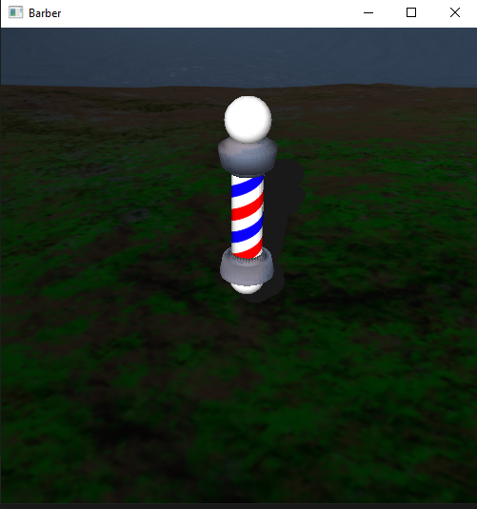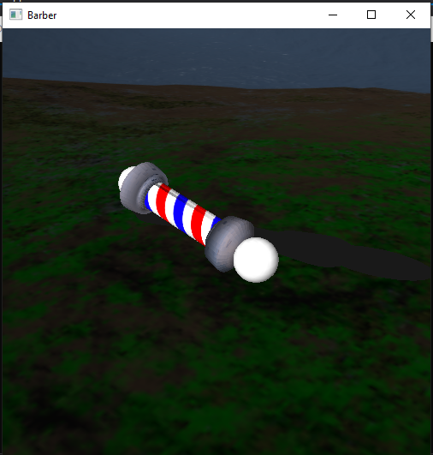

The Pole is formed by 2 Glut spheres, a sweep surface copied and rotated, which was textured have a minor glossy look from one of the provided skybox textures (1,bottom), and the central cylinder which was made with a sweep surface and textured with a custom-made barber pole texture (made using photoshop).

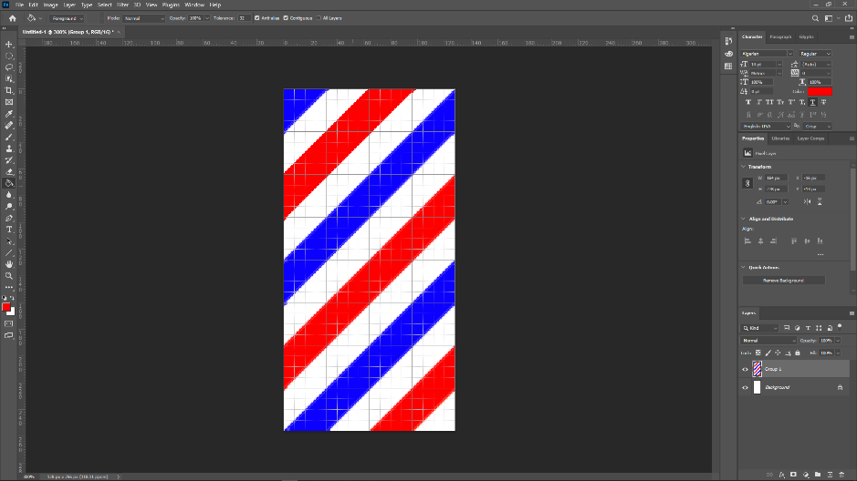

**Extra Features:**

A skybox was implemented using provided textures.

A Planar shadow was cast from the entire pole, which rotates in sync with the pole.

**Controls:**

The arrow keys can be used to navigate the scene:

Left and right change the angle of the camera on the horizontal.

Up and down move the camera forward/backwards in the direction they are facing.

**Building the program:**

The source file is called ProjectBarber.cpp and can be built by navigating to the root directory (../OpenGLProject/OpenGLProject/) and running the command cl /EHsc ProjectBarber.cpp to compile the program, and then running ProjectBarber to build it. Alternatively, open OpenGLProject.sln in an IDE and add the source file to build it through the IDE.